**Question 1**

Determine the steady state for the Markov chain whose transition probability matrix is:

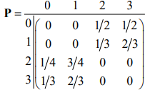

**Question 2**

Consider a simplified monopoly game with only five squares and respective incomes of $200, $0, −$75, $105, and −$130. A player starts at the first square, rolls a fair die once, and moves forward as many steps as the die show.

1. Argue that this game can be modelled as a Markov chain and find its transition probability matrix.
2. Compute the steady-state probability of each square, and find the long-run winning of the player.

**Question 3**

Consider a 5-state Markov chain with the following transition probability matrix.

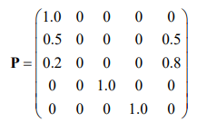

1. Use R to plot a diagram of the Markov chain. Identify all transient and recurrent classes. Identify all absorbing and reflective states. Find the period of each state.
2. Simulate three trajectories of the chain that start at a randomly chosen state. Comment on what you see.
3. Find the steady-state probabilities and interpret them. Is it an ergodic chain?
4. Plot the unconditional probabilities at time n against time and comment on how fast the probabilities converge to the steady-state distribution.